MySQL Coffee_Shop_Sales Analysis
1) Convert the date from text to date format
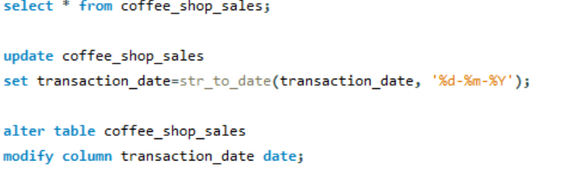
2) Convert the time from text to time format
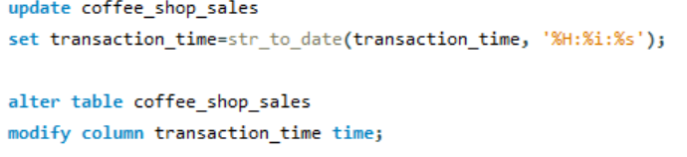
3) Total Sales
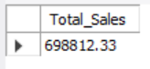
4) Total sales month wise
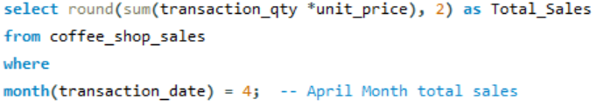
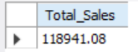
5) MoM increase in percentage
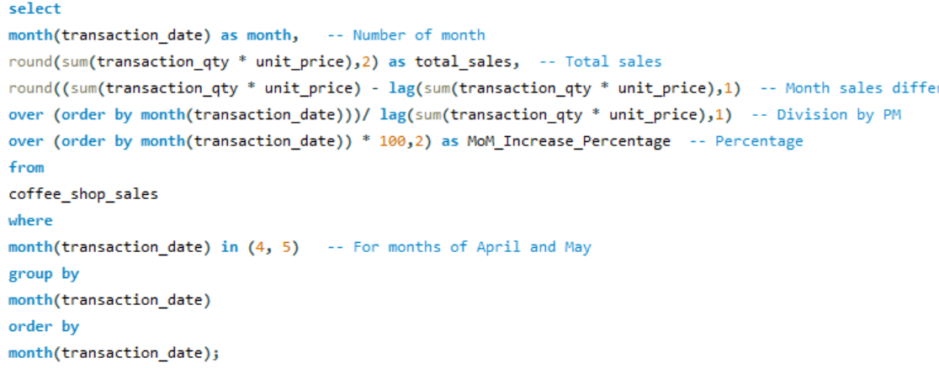
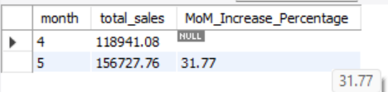
6) Total Orders
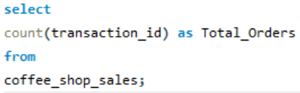
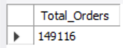
7) Total orders month wise
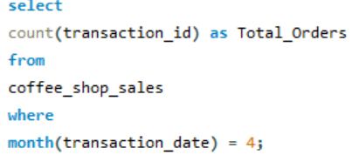
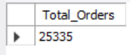
8) MoM increase percentage for Month wise Orders
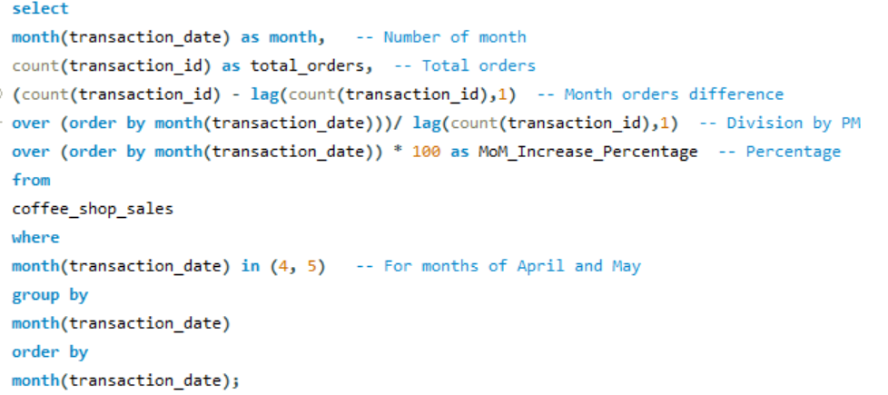
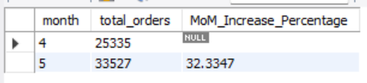
9) Total Quantity Sold
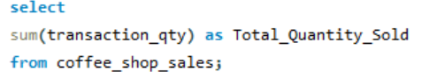
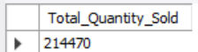
10) Total Quantity Sold Month wise
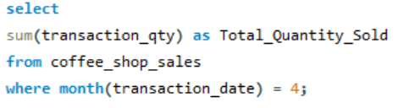
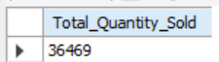
11) MoM increase percentage for Month wise total quantity sold
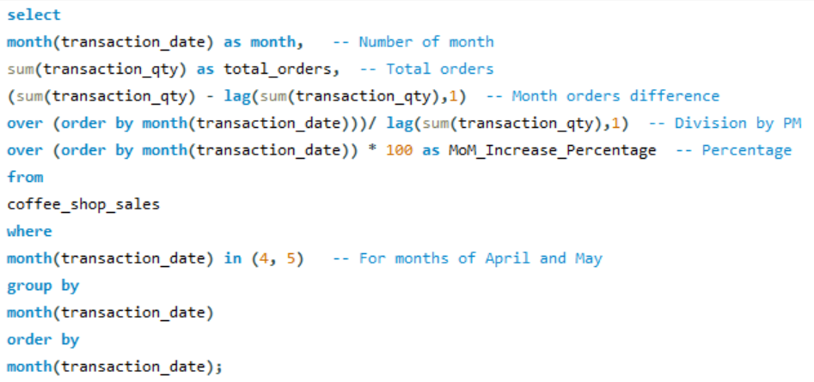
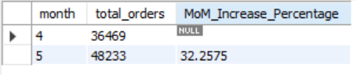
12) Overall Total Sales, Total Orders & Total Quantity Sold
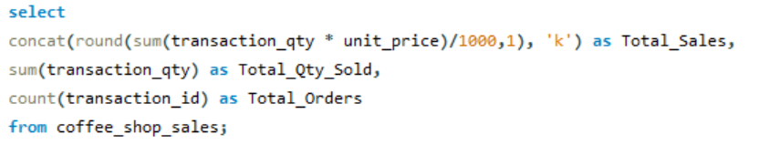
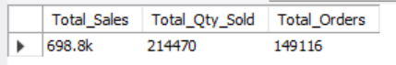
13) Day wise Total Sales, Total Orders & Total Quantity Sold
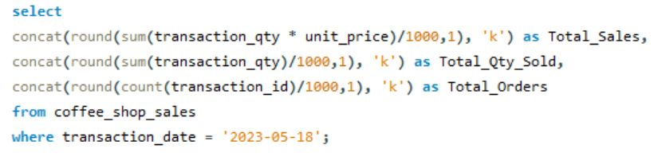
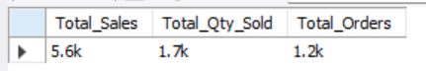
OR
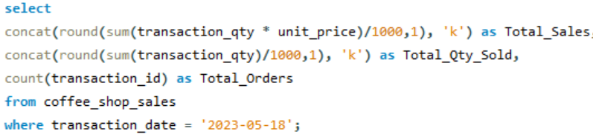
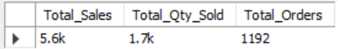
14) Total Sales on weekdays and weekends
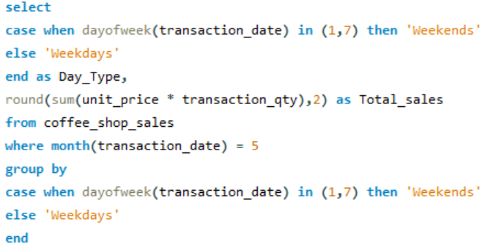
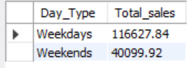
15) Total Sales by Store Locations
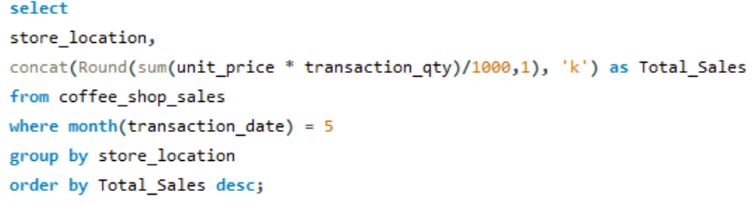
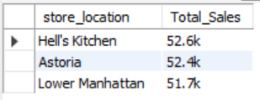
16) Avg Sales for each month
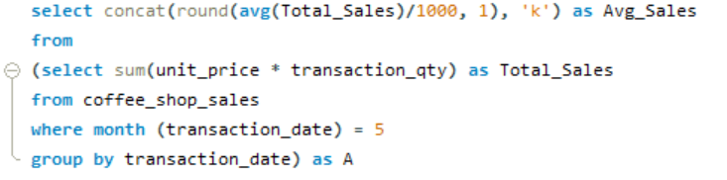
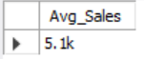
17) Day wise Total Sales for each month
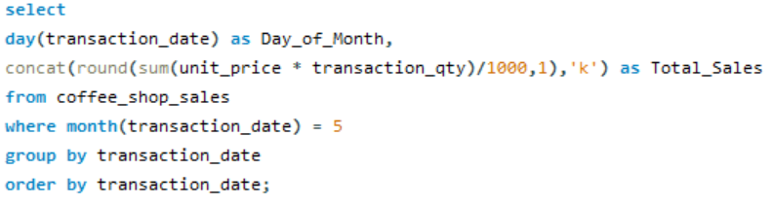
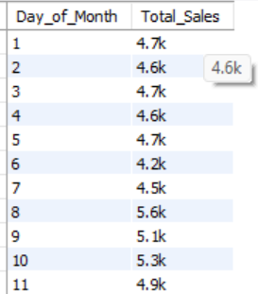
18) Comparing Daily Sales with Average Sales
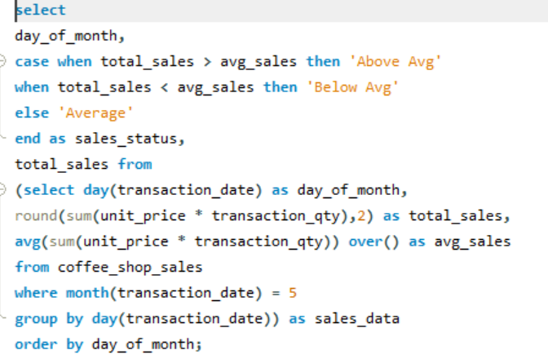
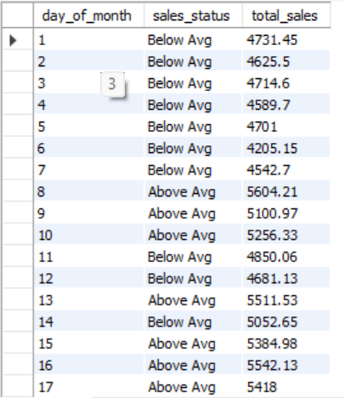

19) Sales by Product Category
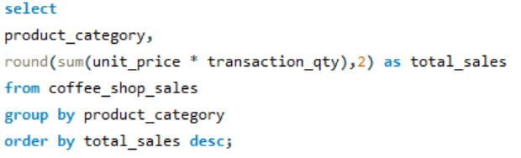
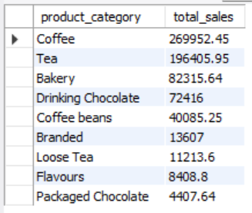
20) Top 10 Product type sales
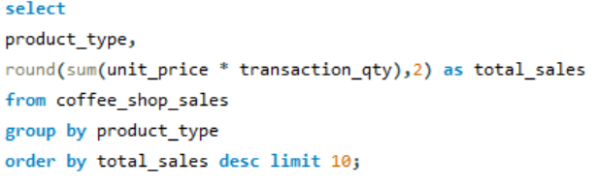
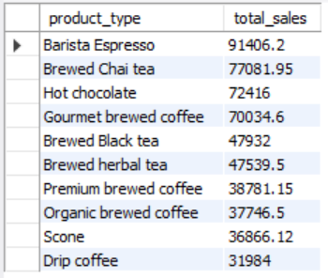
21) Sales by Month Day Hour
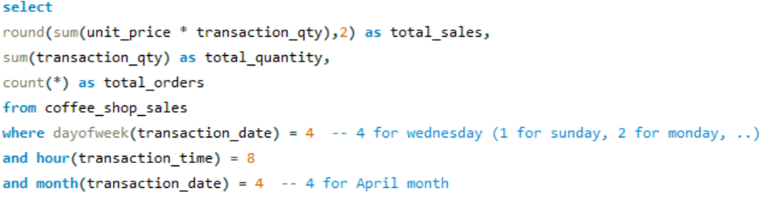
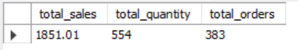
22) To get Sales from Monday to Sunday for the month of May
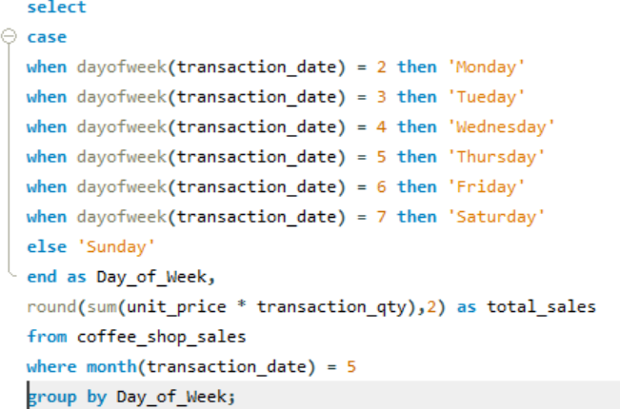
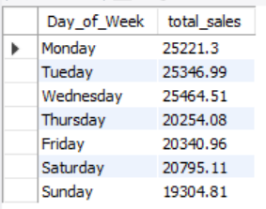
23) To get Sales for all Hours for the month of April
